

**IT-632 Software Engineering**

**Group Id- 03**

**A**

**project report**

**on**

**“Neural Networks for Stock Prediction”**

**Neural Networks for Stock Prediction**

**Faculty guide:** prof. Sourabh Tiwari

**Project mentor:** Varun Shah

**Group member details:**

|  |  |  |
| --- | --- | --- |
| **ID** | **Name** | **Email Id** |
| 202112001 | Vineeta Gurnani | 202112001@daiict.ac.in |
| 202112015 | Atharva Vaze | 202112015@daiict.ac.in |
| 202112041 | Abhinav Kakade | 202112041@daiict.ac.in |
| 202112049 | Varsha Bhootra | 202112049@daiict.ac.in |
| 202112060 | Yash Trivedi | 202112060@daiict.ac.in |
| 202112071 | Aman Goyal | 202112071@daiict.ac.in |
| 202112074 | Karan Patel | 202112074@daiict.ac.in |
| 202112080 | Nurudin Kudarati | 202112080@daiict.ac.in |
| 202112091 | Harshit Agarwal | 202112091@daiict.ac.in |
| 202112096 | Hani Patel | 202112096@daiict.ac.in |
| 202112115 | Divyansh Jain | 202112115@daiict.ac.in |

**Description:**

* In recent times, stock price prediction is an area of profound interest in the realm of the fiscal market.Every day there are millions of people who buy and sell stocks of various companies. Thus, Terabytes or even Petabytes of data are being generated from different exchanges. Financial organizations and retail traders can extract a great amount of information which can help them in their trading decisions. Financial market is largely based on the daily trading of stock so by the use of machine learning techniques one can create prediction models which can predict the stock prices in advance. If we can predict the stock market by analysing historical data properly, we can avoid the consequences of serious market collapse and to be able to take necessary steps to make market immune to such situations.
* The intended combination of sentiment analysis and Neural networks is used to establish a statistical relationship between historic numerical data records of a particular stock and other sentimental factors which can affect the stock prices.
* Long short-term memory (LSTM) is an artificial recurrent neural network (RNN) architecture that you can use in the deep learning field. We can process an entire sequence of data. LSTM has a feedback connection that helps it remember preceding information, making it the perfect model for our needs to do time series analysis.
* A full stack web application is used to display the stock prediction graphs to the user.

Tools & Technology Used: Python, JavaScript, ReactJS, NodeJS, MongoDB

**Objective:**

* The algorithms can reveal complex patterns characterized by non-linearity as well as some relations that are difficult to detect with linear algorithms. These algorithms also prove more effectiveness and multicollinearity than the linear regressions ones.
* Our project's aim is to use ML algorithms based on LSTM for forecasting the adjusted closing prices for a portfolio of assets, the main objective here is to obtain the most accurate trained algorithm, to predict future values for our portfolio.

**Scope**

* With the introduction of Machine Learning and its strong algorithms, the most recent market research and Stock Market Prediction advancements have begun to include such approaches in analysing stock market data.
* The total volume of the stocks in the market is provided, with this information, it is up to the job of a Machine Learning Data Scientist to look at the data and develop different algorithms that may help in finding appropriate stocks values.
* With the application of machine learning for stock market forecasts, the procedure has become much simpler.

**Software Development Life Cycle Model Used:**

**Iterative Waterfall Model**

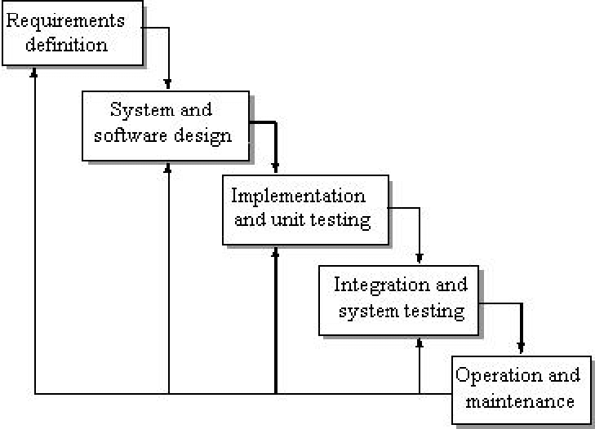

The Iterative Waterfall Model is an extension of the Classic Waterfall Model.

There are some certain adjustments made in the Iterative Waterfall Model to boost the performance of software development.

There is limited customer interaction in our project, and the requirements are defined before starting the development phase.

There is a feedback path from one phase to its preceding stage.

**Users and Stakeholders of the project**

**User**:

1. Users can register, login and create his/her profile.
2. Users can view the stock prediction
3. Users can compare the stock prices.
4. Users can view information about the stock market.
5. Users can also provide feedback.

**Stackholders:**

ADMIN:

1. Admin has all the rights to view the user's activities as he/she is the owner of the website.
2. Admin can compute the performance and result.
3. Admin can view the stock prices.
4. Admin can also view the information about the stock market and update them.
5. Admin can view the feedback provided by the user.

**Other Stakeholders of our project:**

* Government
* Financial Institutes
* Stock Market Investors
* NSE India
* BSE India
* Stock Market Researcher and Analyst
* Investment Research firms

**Requirement Gatherings:**

In this system we used the LSTM to predict the stock prices.

LSTM - The benefit of using a Long Short Term Memory neural network is that there is an extra element of long-term memory, where the neural network has data about the data in prior layers as a 'memory' which allows the model to find the relationships between the data itself and between the data and output.

**Functional and Non-Functional requirement’s as per the process model**

**Functional Requirements**:

These are functions or features that must be included in a system to satisfy the need of the system and the user's expectation. Some of the functional requirements for our system are listed below:-

i. New user registration – Registration of a new user.

ii. The software should accept the .csv dataset as an input only from the admin side.

iii. User login: A registered user can login to the system by providing his user ID and

password as set by him while registering. After successful login, home page for the

user is shown from where he can access the different functionalities.

iv. Users can view data of particular stock according to time period.

v. User can view the opening price and closing price of a particular stock of each day.

vi. Data should be gathered from kaggle.com for more accurate data.

**Non - Functional Requirements**:

These are features that are included in the system on the basis of information, economic terms, security efficiency and services. Some non - functional requirements for our system are listed below:-

i. The system should provide better accuracy.

ii. user should have a simple user interface to interact with the system.

iii. user can also use the predictions of various stock prices to find the correlation and comparison between stocks.

iv. Password reset: If user forgot his password, then he can reset his account

Password.

**Use Case Diagram:**

**Actors**:

Primary Actors: - Primary actors initiate a use case and hence are somewhat independent.

In our Use case diagram, the primary actor is the **User**.

Secondary Actors: - Other actors involved in the Use Case, and they provide services to the System.

In our Use Case diagram, the secondary actor is the **Admin**.

The functionalities that we have considered are as follows: -

1. Register
2. Login
3. Compare
4. View Stock Prediction
5. View Information
6. Feedback
7. Collect Data
8. Compute result and performance

**Register**: Before the utilisation of the web application, it is necessary for both the actors (user and admin) to register themselves. Without this, they cannot proceed further.

**Login**: After the registration process is completed, the user will have to login to access the website by his/her account.

In this, *Verify Password* is included in the functionality of login. Hence, there is a include relationship between *Login* and *Verify Password*.

Also, *Invalid Login Details* would be active once there is an error in the login. Therefore, it is not mandatorily active once login process is active. Therefore, there is an extend relationship between *Login* and *Invalid Login Details.*

**View Stock Prediction**: The details of the company stocks would be made available to the user by the admin. The user would be able to then see the predictions of different stocks.

**Compare**: This can be done only after user login. Comparison between stocks of different companies would be visible here.

**View Information**: The user can find a webpage which has explanation of how we predicted the stock prices.

**Feedback**: User would be able to give his/her feedback which would be recorded for further improvement by the developers.

**Collect Data**: The admin would be responsible to collect the data of various company stocks to be made available to the user for his/her own purpose.

**Compute result and performance**: Upon receiving the different kinds of requests that are made by the user which are available to him/her, the admin will process the request and compute the result accordingly.

